# OOP Lab 8 Outputs

Name: Saahil Ghulam Mohamad

Roll Number: 24K-0570

Section: BCS-2D

Task1: 

Task2: 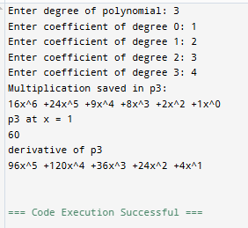

Hw2: 

